Sales Analysis Report

The data belong to store which has a detail description of given columns.

1. Row Id = It belongs to the particular row id in dataset (type = int64)

2. Order ID = It belong to the particular Id order in dataset (type = object)

3. Order date = It is order date of product (type = datetime)

Most order date= 18-06-2015 = 135 order

4. Ship date = after order shipment date (type = datetime)

Most shipped date = 22-11-2015 = #130

5. Ship Mode = type of mode (with values)

Standard Class 30775

Second Class 10309

First Class 7505

Same Day 2701

6. Customer Id = It is particular id to customer from which they are being identified. (type = object)

7. Customer Name = Name of different customer. (type = object)

8. Segment = Type of customers

Consumer 26518

Corporate 15429

Home Office 9343

9. Postal code = the most delivered postal code

10035.0 = 263

10. City = the info of city where it is delivered

Highest delivered city = New York City 915

11. State = Delivered State

Highest California 2001

England 1499

New York 1128

Texas 985

Ile-de-France 981

12. Country = Delivery country

Most delivered country = United States 9994

13. Region = The sales according to region

Highest = Western Europe 5883

Central America 5616

Oceania 3487

14. Market = The highest market opportunity continent

Asia Pacific 14302

Europe 11729

USCA 10378

LATAM 10294

Africa 4587

15. Product Id = It is particular product Id form which product can be identify

16. Category = Type of sold product

Office Supplies 31289

Technology 10141

Furniture 9860

17. Sub Category = Different type of particular Category

Highest = Binders 6146

Storage 5049

Art 4864

Paper 3492

18. Product name = Different product name of sub category

Highest = Staples 227

Cardinal Index Tab, Clear 92

Eldon File Cart, Single Width 90

Rogers File Cart, Single Width 84

19. Sales = Price of product.

20. Quantity = Number of products sold.

21. Discount = The percent of Discount given of different product

22. Profit = Net profit after discount and expenses (shipment is not included)

23. Shipping cost = Cost to delivered the product

24. Order Priority = Customer preferences

Medium 29433

High 15501

Critical 3932

Low 2424

Segment order as per category

Three types of segments with their category orders

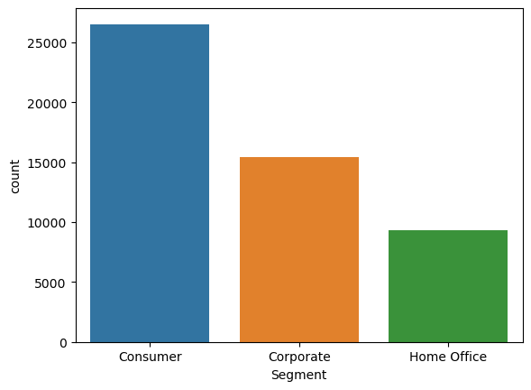

Consumer Office Supplies 16159

Technology 5272

Furniture 5087

TOTAL 26518

Corporate Office Supplies 9369

Technology 3051

Furniture 3009

TOTAL 15429

Home Office Technology 1818

Furniture 1764

Office Supplies 5761

TOTAL 9343

As per data consumer is the most ordered community with 51.70% of total orders.

Market order as per category

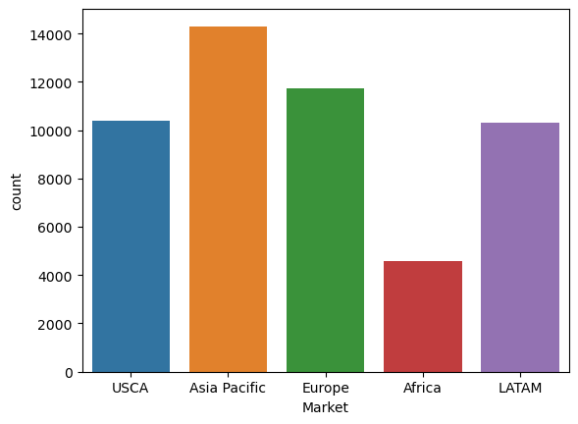

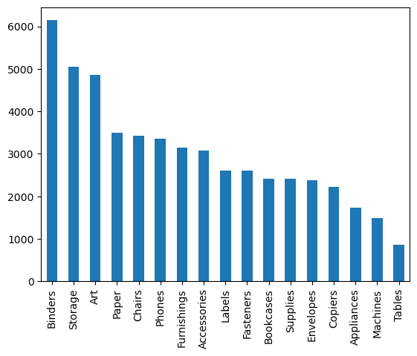

Continent wise category orders

Asia Pacific Office Supplies 8345

Technology 3034

Furniture 2923

Total 14302

Europe Office Supplies 7718

Technology 2234

Furniture 1777

Total 11729

USCA Office Supplies 6319

Furniture 2147

Technology 1912

Total 10378

LATAM Office Supplies 5862

Furniture 2382

Technology 2050

Total 10294

Africa Office Supplies 3045

Technology 911

Furniture 631

Total 4587

Therefor the most delivered continent is Asia pacific with 27.88% of total delivery.

Category distributed in other sub categories

Three categories are divided into another sub categories.

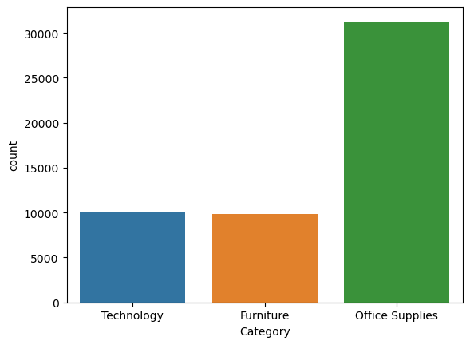

Office Supplies Binders 6146

Storage 5049

Art 4864

Paper 3492

Labels 2601

Supplies 2407

Appliances 1742

Fasteners 2601

Envelopes 2387

Total 31289

Furniture Chairs 3434

Furnishings 3154

Bookcases 2411

Tables 861

Total 10141

Technology Phones 3357

Accessories 3075

Copiers 2223

Machines 1486

Total 9860

Comprehensive analyses of hole data

In this data the total 1,78,312 quantity to be sold and the worth of these quantity is 1,26,42,501.

Products cost= 98,16,959

Average discount 0.14% on hole 51,290 transaction.

Gross profit = 28,25,542

Shipping cost = 13,58,085

Net profit on hole transition = 14,67,457

As per analysis the company should prepare a specific model to reduce shipping cost because it charges 48.06% of total profit.

Suggest Suggestion to increase profit.

1. As in this chart less quantity order is to be given

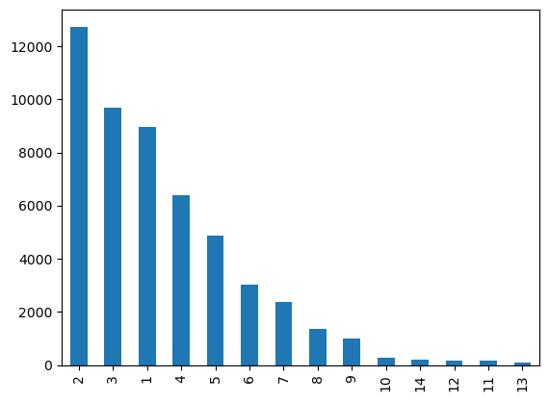

More Quantity of product can be shipped by giving extra discount on bulk purchase

1. By Giving more discount on low purchasing Region and start increasing a bench mark profit on high ordering Region.
2. Start charging a bit of shipping charges on same day delivery items and on high eliding shipping cost.
3. By giving discount on not repeated customers.
4. Start hybrid model of shipment.

Merge column with values

a= df["Category"],df['Sales']

b =pd.DataFrame(a)

c =b.T

c.value_counts()